1. Create an android app with single activity which contains Registration form for user with submit button. Display success toast message when user submit if all the details are filled by user else show error toast message.
2. Design following Layout in Android and perform the specified action.

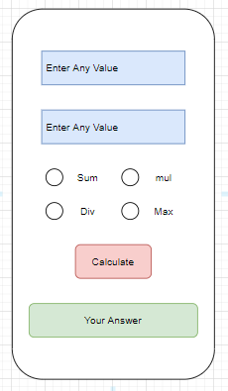

1. Create full screen activity to get User Email and Password from user as shown in Figure. Show on Toggle Button for Accept Terms and Condition, Show Login Button only If Toggle Button is ON. And Hide the Login Button if Toggle Button is OFF.

